# SQL Assignment 1

Note : Queries to look at the exact table have been included to just understand the table and columns available.

## Q1. Do we have actors in the actor table that share the full name and if yes display those shared names.

Answer: Yes, we do. The shared name is Susan Davis.

1. Required query

**SELECT first_name, last_name FROM actor**

**GROUP BY first_name, last_name**

**HAVING COUNT(actor_id) >= 2**

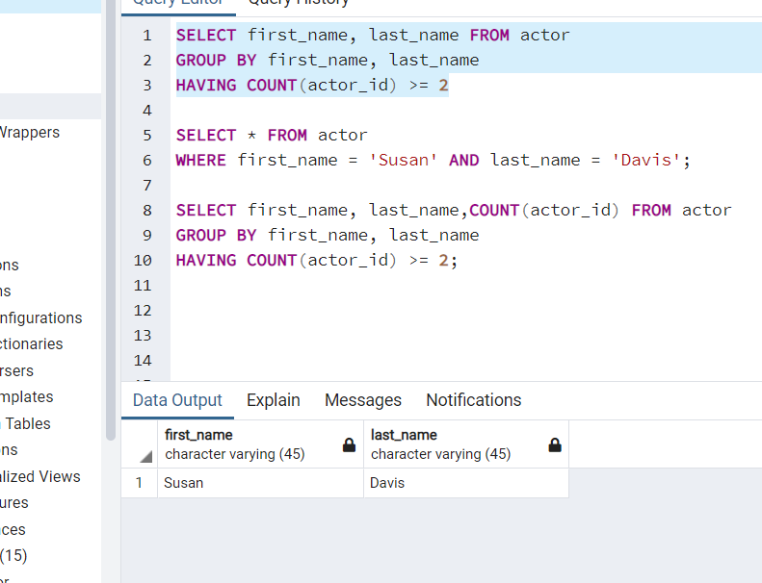

2. Just validating the findings.

**SELECT * FROM actor**

**WHERE first_name = 'Susan' AND last_name = 'Davis';**

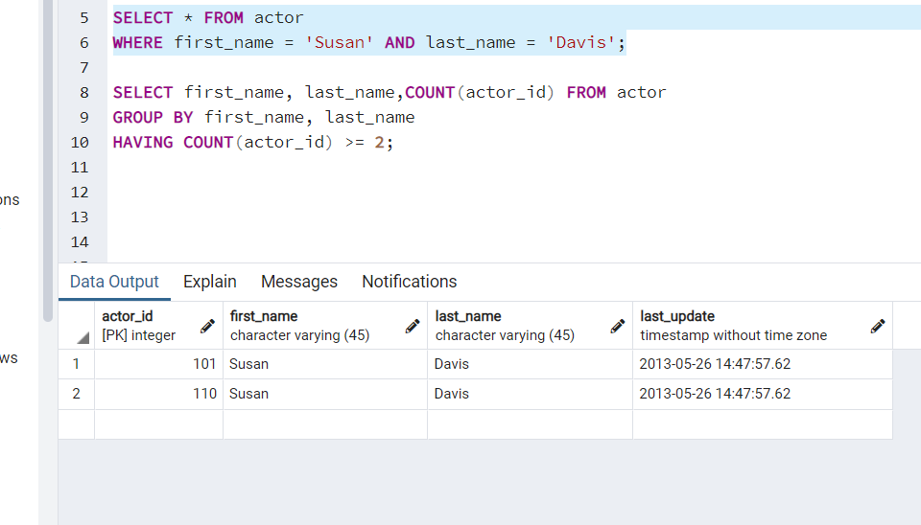

3. A more organised answer.

**SELECT first_name, last_name,COUNT(actor_id) FROM actor**

**GROUP BY first_name, last_name**

**HAVING COUNT(actor_id) >= 2;**

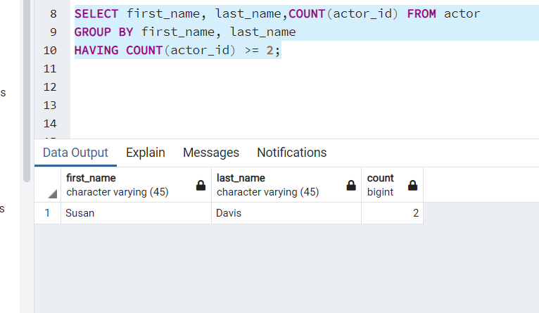

­­­­­

## Q2. Return the customer IDs of customers who have spent at least $110 with the staff member who has an ID of 2.­

**SELECT * FROM payment;**

2. Required answer

**SELECT customer_id FROM payment**

**WHERE staff_id = 2**

**GROUP BY customer_id, staff_id**

**HAVING SUM(amount) >= 110**

**ORDER BY customer_id ASC;**

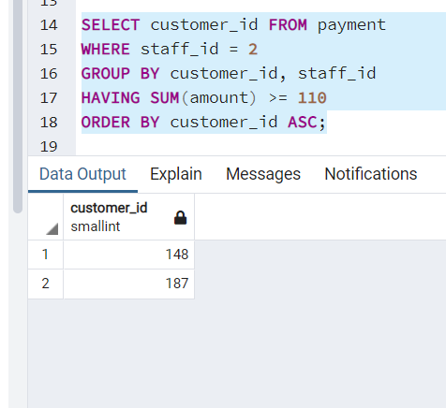

3. A better, oragnised answer.

**SELECT customer_id,staff_id, SUM(amount) FROM payment**

**WHERE staff_id = 2**

**GROUP BY customer_id, staff_id**

**HAVING SUM(amount) >= 110**

**ORDER BY customer_id ASC;**

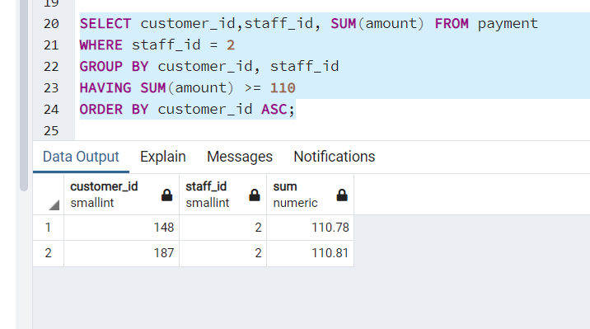

## **Q3.** How many films begin with the letter J?

Answer: 20 Films.

**SELECT * FROM film;**

**SELECT COUNT(film_id) FROM film**

**WHERE title ILIKE 'j%';**

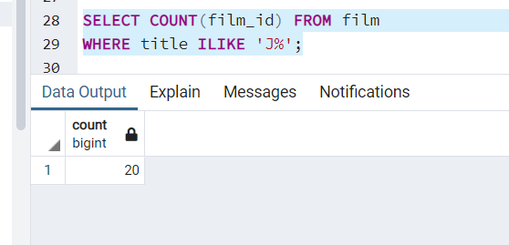

## **Q4.** What customer has the highest customer ID number whose name starts with an 'E' and has an address ID lower than 500?

Answer : Eddie Tomlin whose customer_id is 434 fulfils the given criteria.

**SELECT * FROM customer;**

**SELECT customer_id, first_name, last_name FROM customer**

**WHERE first_name LIKE 'E%' AND address_id < 500**

**ORDER BY customer_id DESC**

**LIMIT 1;**

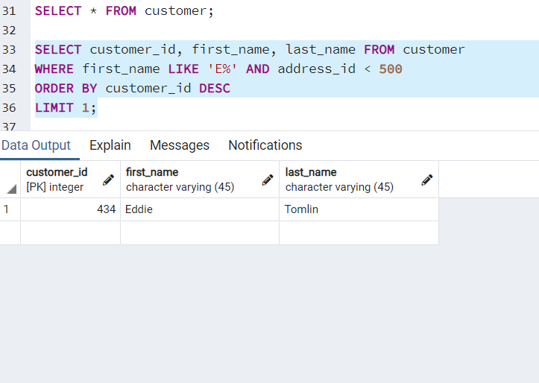

## **Q5.** How many films have the word Truman somewhere in the title?

Answer: 5 Films.

**SELECT * FROM film;**

**SELECT COUNT(film_id) FROM film**

**WHERE title ILIKE '%Truman%';**

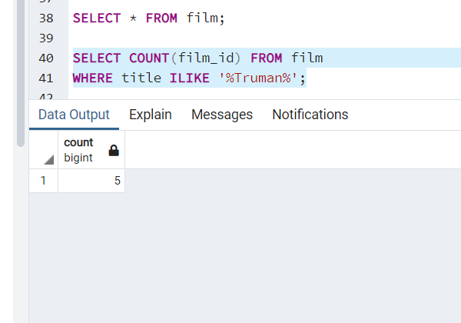

## **Q6.** Display the total amount payed by all customers in the payment table.

Answer: Total amount paid was $61312.04

**SELECT * FROM payment;**

**SELECT SUM(amount) FROM payment;**

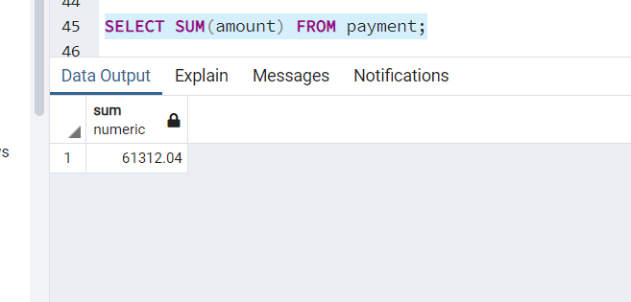

## **Q7.** Display the total amount payed by each customer in the payment table.

**SELECT * FROM payment;**

**SELECT customer_id,COUNT(customer_id) as Total_Transactions,SUM(amount) as total_amount_paid**

**FROM payment**

**GROUP BY customer_id**

**ORDER BY SUM(amount) DESC;**

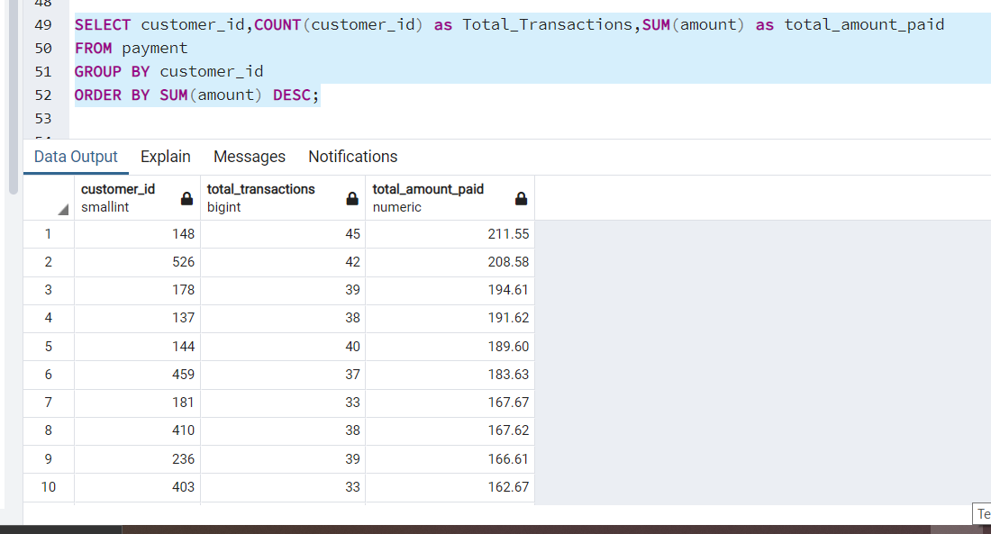

## **Q8.** What is the highest total_payment done.

Answer $211.5 , assuming this refers to highest total payment made by a single person.

**SELECT * FROM payment;**

**SELECT customer_id,COUNT(customer_id) as Total_Transactions,SUM(amount) as total_amount_paid**

**FROM payment**

**GROUP BY customer_id**

**ORDER BY SUM(amount) DESC**

**LIMIT 1;**

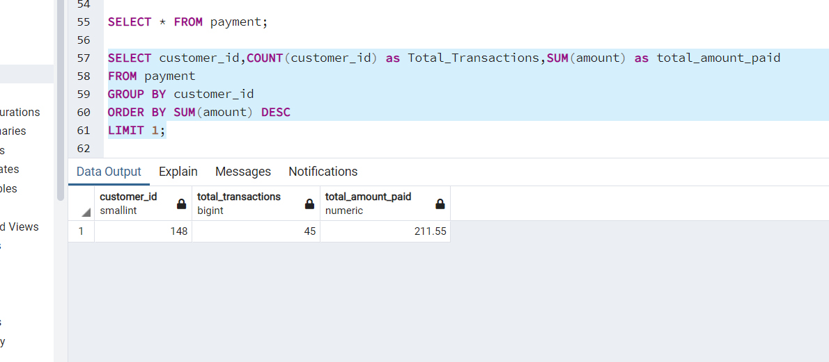

## **Q9.** Which customers have not rented any movies so far.

**SELECT * FROM customer;**

**SELECT customer_id FROM customer**

**WHERE active = 0;**

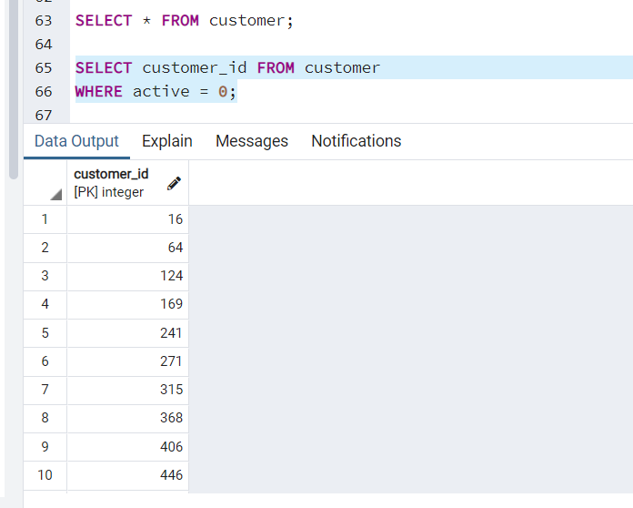

## **Q10.** How many payment transactions were greater than $5.00?

Answer: 3618 transactions

**SELECT * FROM payment;**

**SELECT COUNT(payment_id) FROM payment**

**WHERE amount > 5;**

